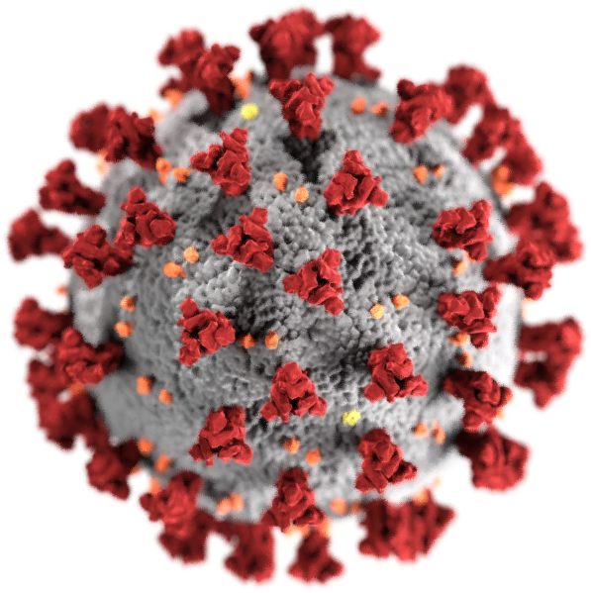
International Conference on Covid-19 Pandemic & Religious Freedom:
Reports from North America and Europe
December 2-3, 2020
(All times listed are EST; Add five hours for GMT, subtract 3 for PST)

Wednesday, December 2

10:00 AM to 10:05 AM – Welcome & Introduction
Nicholas Miller, Andrews University & Alexis Artaud de La Ferrière, University of Portsmouth
Ambassador John Nay, President of the International Religious Liberty Association

10:05 AM to 11:35 AM – Panel 1 – Report from Europe - I
Chair, Alexis Artaud de La Ferrière, University of Portsmouth
Louis-Léon Christians, U.C. Louvain, “Religion and Covid-10 in Belgian Law”
Ganoune Diop, General Conference of Seventh-day Adventists, “The First Human Right During Time of Pandemic: Exploring the Moral Foundation for Human Solidarity”
Alejandro González-Varas Ibanez, the University of Zaragoza (Spain) School of Law, “Law, Religion, and Coronavirus between the United States and the European Union”
Jean-François Mayer, Institut Religioscope, Fribourg , “How essential? Meanings and perceptions of religion during the Covid-19 pandemic”

12 noon to 1:30 PM – Panel 2 – Report from North America - I
Chair, Nicholas P. Miller, International Religious Liberty Institute, Andrews University
Kathleen Brady, Emory University, “COVID-19 and Restrictions on Religious Institutions: Constitutional Implications”
Caroline Mala Corbin, University of Miami School of Law, “Religious Liberty in a Pandemic: Constitutional Challenges to Mass Gathering Bans”
Andrew Lewis & Daniel Bennett, University of Cincinnati & John Brown University, “Church Closures, Religious Freedom, and the Coronavirus Pandemic: Assessing the Christian Legal Movement’s Response”
Christopher Lund, Wayne State University Law School, “Quarantines, Religious Groups, and Questions of Equality”

Register at https://www.covid-religiousliberty.org/events
For questions about the conference: e-mail nmiller@freedom-law.com and janna.quetz@lakeunion.org
Sponsored by Andrews University, BYU Law School Center for Law and Religion Studies, and University of Portsmouth
International Conference on Covid-19 Pandemic & Religious Freedom:
Reports from North America and Europe
Page 2

Thursday, December 3

10 AM to 11:30 AM – Panel 1 – Report from Europe - II
Chair, Rosa Maria Martinez de Codes, University Complutense of Madrid
Ibrahim Salama & Michael Wiener, Office of the UN High Commissioner for Human Right, “Responding to pandemics: peer-to-peer learning with the #Faith4Rights toolkit”
Alessandro Ferrari, University of Insubria, “Covid-19 & religious freedom in Italy; the resilience of the ‘exceptional right’"
Blandine Chelini-Pont, Aix-Marseille Université, “From soft to angry attitudes against the temporary suspensions of public worship in France”

12 noon to 1:30 pm – Panel 2 – Report from North America - II
Chair, Brett Scharffs, J. Reuben Clark Law School, Brigham Young University
W Cole Durham Jr., J. Reuben Clark Law School, Brigham Young University, “Coronavirus, the Compelling State Interest in Health, and Religious Autonomy”
Jeffrey Hammond & Michael DeBoer, Faulkner University, Thomas Goode Jones School of Law, “Conflicts between Religious liberty and the New Public Health”
Dwight Newman, University of Saskatchewan, “When the State Tells You How to Run Your Church Service: Analyzing coronavirus Guidance Documents on Religious Services”
1:30 PM to 2:15 PM – Closing Discussion of Future Follow Up Project on Pandemic and Religious Freedom
Conference Organizers – Nicholas Miller, Alexis Artaud de La Ferrière, Rosa Maria Martinez de Codes, Brett Scharffs, Cole Durham.

Register at https://www.covid-religiousliberty.org/events
For questions about the conference: e-mail nmiller@freedom-law.com and janna.quetz@lakeunion.org
Sponsored by Andrews University, BYU Law School Center for Law and Religion Studies, and University of Portsmouth

